
UT/GEAK/1223/A 09-NOV-2023
UNIT TEST (2023-24)
(ANSWER KEY)
Subject: GEOGRAPHY  Grade: XII |  | Max. Marks: 50  Time: Hours
SECTION A
(OBJECTIVE TYPE QUESTIONS)
1. | Why cannot products of gathering compete in the world market? |  | 1
 | (a) Close market concept | (b) Availability of less price synthetic products
 | (c) Use of old technology | (d) None of the Above
2 | The open-cast mining is the easiest and the _________ way of mining minerals |  | 1
 | (a) useless | (b) expensive
 | (c) cheapest | (d) admirable
3. | Arrange the countries from the highest to the lowest on total road network :  (i) United States of America (ii) India (iii) China (iv) Brazil |  | 1
 | (a) i, ii, iii, iv
 | (b) iv, ii, iii, i
 | (c) iii, iv, i, ii
 | (d) i, iii, ii, iv
4. | ____________ is a powerful medium of collecting information from the computer. |  | 1
 | (a) Satellite | (b) Internet
 | (c) Television | (d) Laptop
5 | . _________ is an information system where documents and other web resources are identified by Uniform Resource Locators, which may be interlinked by hyper links, and are accessible over the Internet. |  | 1
 | (a) World wide wed | b) World wide web
 | (c) World wide world | (d) World wide watch

6 | Assertion (A): Transport is a service or facility for the carriage of persons and goods from one place to the other using humans, animals and different kinds of vehicles.  Reason (R): Such movements take place over land,water and air |  |  | 1
Directions : In the following questions,
A statement of Assertion (A) is followed by a statement of Reason (R).
Mark the correct choice as:
(A) Both A and R are true and R is the correct explanation of A.
(B) Both A and R are true but R is NOT the correct explanation of A.
(C) A is true but R is false.
(D) A is false and R is true.
7 | Which one pair of the following places is linked by Channel Tunnel?
 | (a) London- Berlin |  | (b) Berlin -Paris
 | (c) Paris- London |  | (d) Barcelona- Berlin
8 | The terminal points of North- South Corridor are: |  |  | 1
 | (a) Srinagar to Kanyakumari |  | (b) Jaisalmer to silchar
 | (c) Delhi to Chennai |  | (d) Amritsar to Bangalore
9 | ------------------ is the largest government undertaking in India. |  |  | 1
 | (a) Air India |  | (b) National waterways
 | (c Indian Railways |  | (d) Pipelines
10 | Which of the following is NOT a land -use category? |  |  | 1
 | (a) Fallow land |  | (b) Marginal Land
 | (c) Net sown area |  | (d) Culturablewaste land
11. | ________ is a short duration summer cropping season. |  |  | 1
 | (a)zaid | (b)rabi
 | (c)kharif | (d)none of the above
12. | Which of the following crop is sown under both kharif and rabi season in southern India |  |  | 1
 | (a) Maize |  | (b) Pulses
 | (c) Bajra |  | (d) Jowar
SECTION B
SOURCE BASED QUESTION
13 | Read the case study given below and answer the questions that follow:
13.1 | Open-cast mining |  | 1
13.2 | Shaft mining |  | 1
13.3 | Why developed economies are retreating from mining, processing and refining stages of production? Because of High lab our cost |  | 1
SECTION C
SHORT ANSWERS
14. | A group of farmers form a co-operative society by pooling in their resources voluntarily for more efficient and profitable farming. Individual farms remain intact and farming is a matter of cooperative initiative. Co-operative societies help farmers, to procure all important inputs of farming, sell the products at the most favourable terms and help in processing of quality products at cheaper rates |  | 3
15. | Observe the given map and answer the following questions:  - ANS: Railway Line- Trans-Siberian Railway Line. It Lies in Asiatic Russia  2) Station A is Moscow. Station B is Chita.  3)● It has helped in opening its Asian region to west European markets.  ● Chita is an important agro-centre and Irkutsk, a fur center connecting them to Odessa in the South. |  | 3
16. | Any three National Waterways in India.  NW 1 Allahabad-Haldia stretch (1,620 km) It is one of the most important waterways in India, which is navigable by mechanical boats up to Patna and by ordinary boats up to Haridwar  NW 2 Sadiya-Dhubri stretch (891 km) Brahmaputra is navigable by steamers up to Dibrugarh (1,384 km) which is shared by India and Bangladesh  NW 3 Kottapuram-Kollam stretch (205 km) It includes 168 km of west coast canal along with Champakara canal (14 km) and Udyogmandal canal (23 km).  NW 4 Specified streches of Godavari and Krishna rivers along with Kakinada Puducherry stretch of canals (1078 km)  NW 5 Specified stretches of river Brahmani along with Matai river, delta channels of Mahanadi and Brahmani rivers and East Coast canals (588km) |  | 3
17. | The strategy of increasing crop intensity aims at increasing the productivity of a piece of land by increasing the number of times it is cultivated in a year. It aims at increasing the productivity of agriculture by increasing the productivity of already cultivated area. It is important for country like India where there is dearth of land so it is difficult to bring new pieces of land under cultivation to meet the ever-increasing demand of rising population. |  | 3
SECTION D
LONG ANSWERS
18. | ‘Truck Farming’-  The regions where farmers specialise in vegetables only, the farming is know as truck farming.  In addition to market gardening, a modern development in the industrial regions of Western Europe and North America is factory farming.  Livestock, particularly poultry and cattle rearing, requires heavy capital investment in terms of building, machinery for various operations, veterinary services and heating and lighting. One of the important features of poultry farming and cattle rearing is breed selection and scientific breeding |  | 1+1+3
19. | The role of roads in the economic development of India.  *Road transport is the basis of not only economic development but also social development, defense sectors, and access to basic things for life.  *According to a report, about 85 percent of passenger and 70 percent of goods traffic is carried by roads every year, this gives us an idea of ​​its importance.  *Road transport is best suited for short distances and it directly connects producers with consumers.  *Road network is vital for transporting defense equipment to the border.  *The construction of road networks provides employment to lakhs of people directly and indirectly.  *Urbanization is seen with the development of road networks and hence facilitates the urbanization process. |  | 5
20. | The drawbacks of agriculture present in India.  - Dependence on erractic monsoon  - Low productivity  - Constrains of financial resources  - Lack of land reforms  - Lack of commercialization (Ellobrate on the statements) |  | 5
SECTION - E
MAP QUESTIONS
21 | Identify the following on the political map of the world.  A. Name the shipping canal between North and South America -PANAMA CANAL  B. Name the busiest international airport of Germany- HAMBURG  C. Name the important airport of Australia.- DARWIN  D. Name the major airport in Japan-TOKIYO |  | 4
22 | On the outline map of India indicate and mark the following features (any 4)  1) Kandla Port  2) Kochi Port  3) An international airport in Maharashtra  4) Delhi International airport  5) A major port in west Bengal 1x5=5  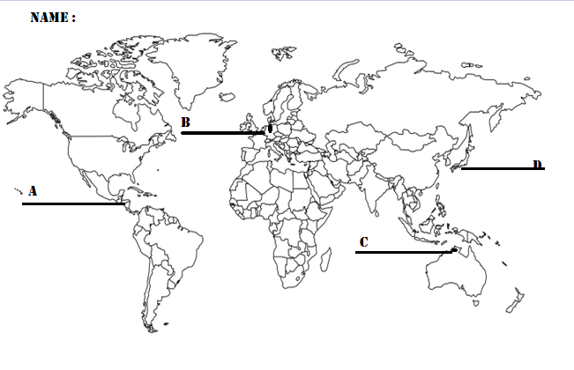 |  | 4

ROLL NO:
CLASS:
